LAB 1 – Raja Aadhithan
Design - Full adder using Half adder:

Wave:
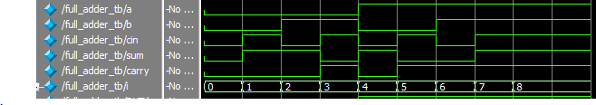

Output:
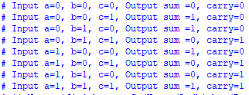

RTL:
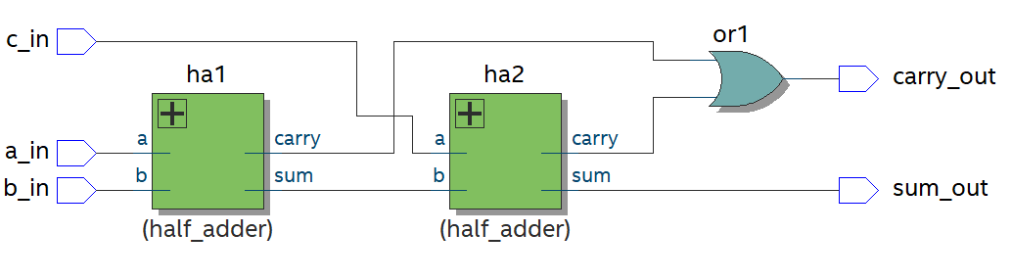

Exercises:
Design : Ripple adder
Wave:
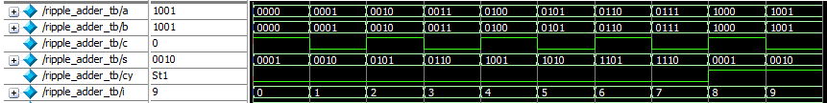
Output:
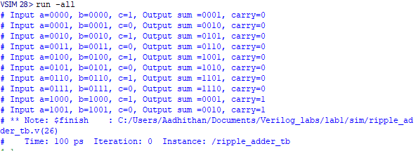
RTL:
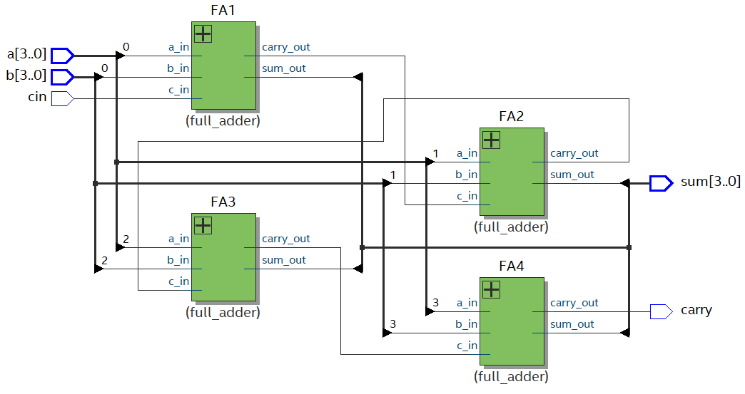
Design : 4:1 mux using 2:1 mux

Wave:
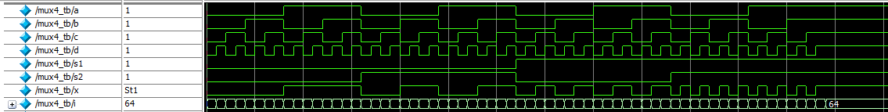

Output:
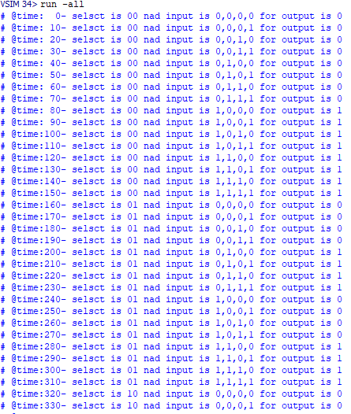
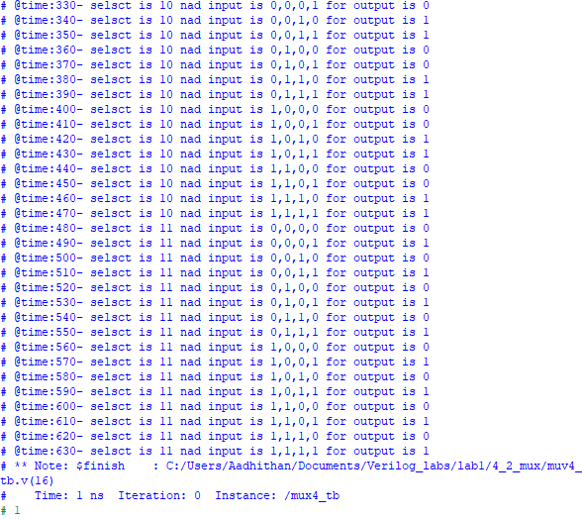
RTL:
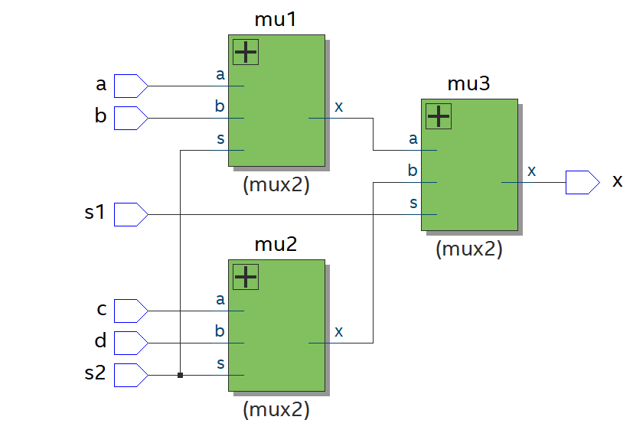
Assignment:
Design: RTL for full adder.
RTL:
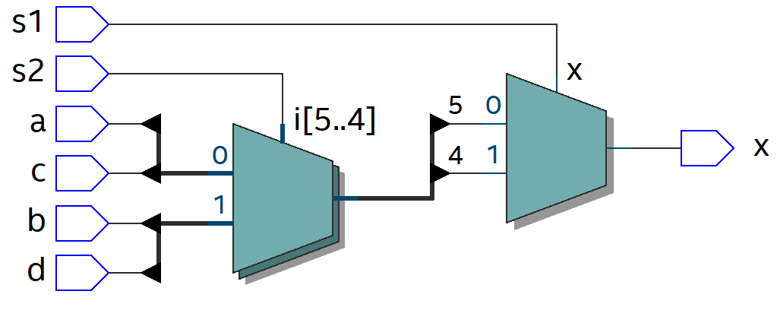
Design: 2x4 decoder.
RTL:
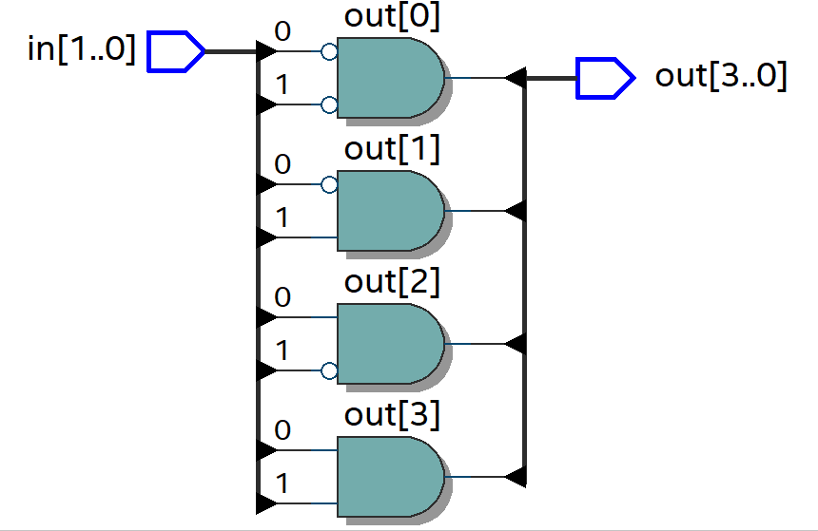
Design: 8x3 priority encoder.
Wave:
Output:
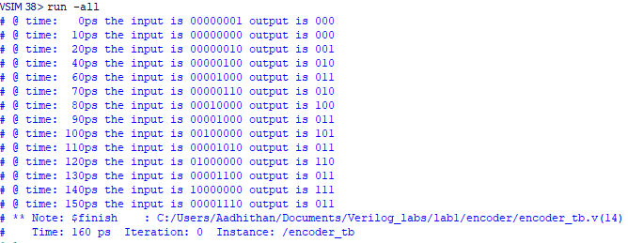
RTL:
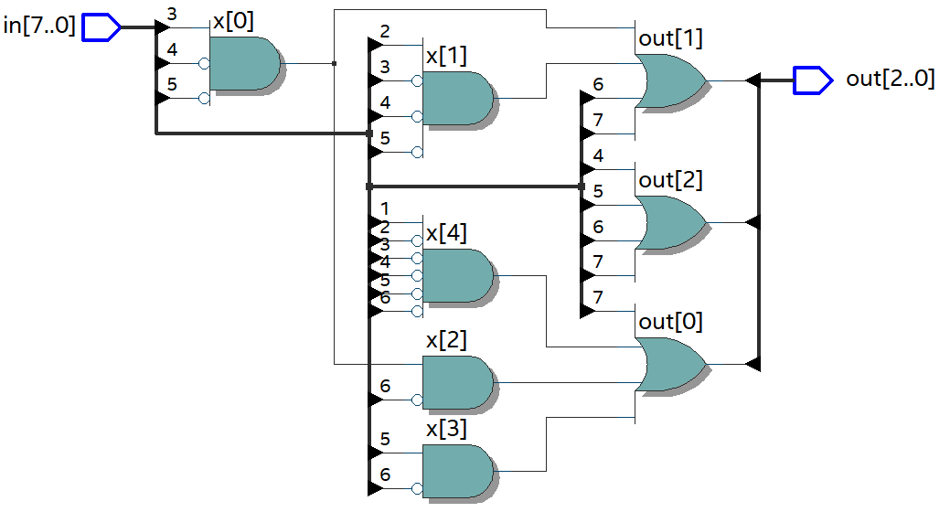
Design: 4x1 mux.

Wave:
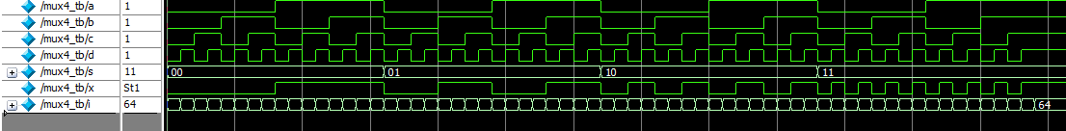

RTL:
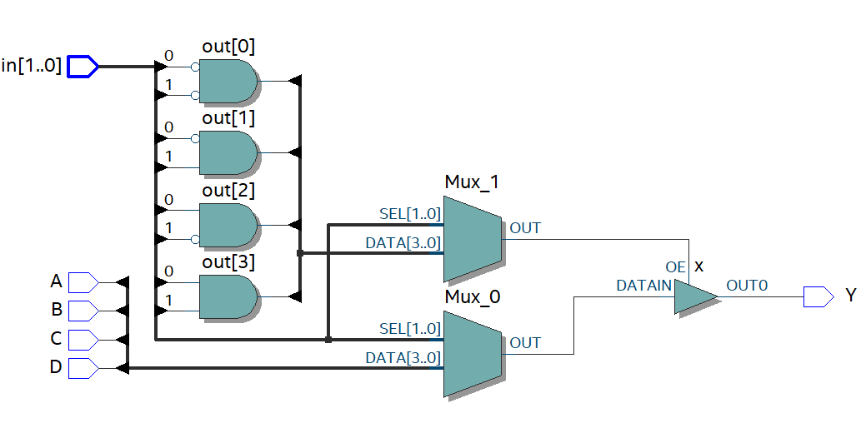
Design: Bidirectional buffer
Wave:
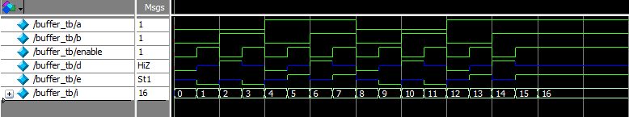
Output:
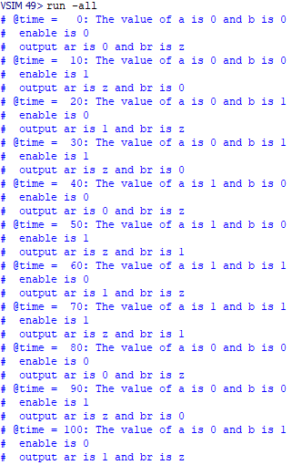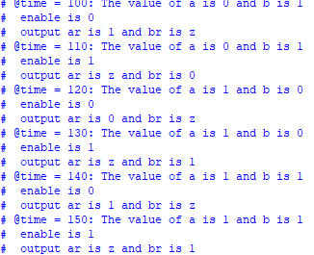

RTL:
